**COMSATS University Islamabad, Abbottabad Campus**

**Department of Computer Science**

**Project Proposal**

**UNIVERSITY TIMETABLE GENERATION SYSTEM**

**CSC392 Object Oriented Software Engineering**

Submitted on: <3/April/2023 >

Group Members:

BASIT IQBAL (FA21-BSE-050)

Fatima Aftab (FA21-BSE-088)

Essa Masood (FA21-BSE-086)

Ebadat Nissa (FA21-BSE-085)

Ahmed Tariq (FA21-BSE-048)

Waleed Rashid (FA21-BSE-162)

Table of Contents

CHAPTER 1 PROJECT PROPOSAL 5

Introduction 5

Vision and Business Case 5

Use-Case Model 6

1. Functional Requirements: 6

Supplementary Specification 6

Glossary 7

Risk List & Risk Management Plan 8

CHAPTER 2 USE CASES 10

2.1 Use Case Diagram 10

2.2 Use Cases Distribution 11

2.3 Brief Level Use Cases 12

Eissa Masood (FA21-BSE-086) 12

Use Case: Allocate Courses 12

Eissa Masood (FA21-BSE-086) 12

Use Case: Select Teacher 12

Ebadat Nissa Khan (FA21-BSE-085) 12

Use Case: View time table 12

Ebadat Nissa Khan (FA21-BSE-085) 12

Use Case: View time student table 12

Ebadat Nissa Khan (FA21-BSE-085) 13

Use Case: View teacher time table 13

Ahmed Tariq (FA21-BSE-048) 13

Use Case: Set Semester Course 13

Ahmed Tariq (FA21-BSE-048) 13

Use Case: Set Criteria 13

Ahmed Tariq (FA21-BSE-048) 14

Use Case: Set Constrains 14

Waleed Rashid (FA21-BSE-162) 14

Use Case: Manage slots. 14

Fatima Aftab (FA21-BSE-088) 14

Use Case: Generate Timetable 14

Fatima Aftab (FA21-BSE-088) 14

Use Case: Modify Timetable 14

2.4 Fully Dressed Use Cases 16

BASIT IQBAL (FA21-BSE-050) 16

Use Case UC1: Login 16

BASIT IQBAL (FA21-BSE-050) 17

Use Case UC2: Log out 17

Waleed Rashid(FA21-BSE-162) 19

Use Case UC1: Manage slots 19

Eissa Masood (FA21-BSE-086) 22

Use Case UC1: Allocate Course 22

Eissa Masood (FA21-BSE-086) 24

Use Case UC1: Select Teacher 24

Ahmed Tariq (FA21-BSE-048) 26

Use Case UC1: Manage slots 26

Ahmed Tariq (FA21-BSE-162) 28

Use Case UC1: Add courses 28

Ahmed Tariq (FA21-BSE-162) 31

Use Case UC1: Manage rooms 31

FATIMA AFTAB (FA21-BSE-088) 33

Use Case UC4: Generate Timetable 33

FATIMA AFTAB (FA21-BSE-088) 35

Use Case UC5: Modify timetable 35

CHAPTER 3 DOMAIN MODEL 38

3.1 Individual Partial Domain Model 38

UC 1,2 : Login & Logout (BASIT IQBAL ,FA21-BSE-050) 38

UC 3,4 : Generate Timetable and Modify timetable (Fatima Aftab,Fa21-bse-088) 39

Manage slots(Waleed Rashid, FA21-BSE-162) 40

CHAPTER 4 SYSTEM SEQUENCE DIAGRAM 41

4.1 System Sequence Diagram of each Scenario 41

4.1.1 LOGIN (BASIT IQBAL : FA21-BSE-050) 41

4.1.2 Logout (BASIT IQBAL : FA21-BSE-050) 42

4.1.3 Generate Timetable Scenario (Fatima Aftab) 43

4.1.4 Modify Timetable Scenario (Fatima Aftab) 44

44

4.1.5 Manage Slots (Waleed Rashid) 45

# CHAPTER 1 PROJECT PROPOSAL

## Introduction

As we know, one of the major challenges faced by universities is creating a timetable that meets the needs of both students and faculty. The current system of manual timetable generation is time-consuming, error-prone, and often results in scheduling conflicts that are difficult to resolve.

The proposed system will be a desktop application that automates the timetable generation process. The system will take into consideration the constraints and requirements of both students and faculty, such as slots, professor availability, room availability. The system will also be customizable, allowing for the inclusion of specific course preferences and restrictions.

The benefits of this proposed system are numerous. Firstly, it will eliminate the need for manual timetable generation, reducing the potential for errors and inconsistencies. Secondly, it will increase the efficiency of the timetable generation process, freeing up valuable time for administrators to focus on other important tasks. Lastly, it will improve the student **experience** by providing them with a timetable that is tailored to their specific needs, ensuring that they have access to the classes they need at times that are convenient for them.

## Vision and Business Case

Vision

The main objective of the Timetable Management System is to manage the details of Timetable, Faculty, Subject, Student, Course. It manages all the information about Timetable, Semester, Course, Timetable. The project is totally built at administrative end and thus only the administrator is guaranteed access.

Business cases:

Cost savings: The implementation of a University Timetable Management System can save the university significant costs by automating the scheduling process and reducing the need for manual labor. By streamlining the scheduling process, the university can reduce administrative costs, increase operational efficiency, and allocate resources more effectively.

Improved student retention: A University Timetable Management System can contribute to improved student retention rates by providing students with an easy-to-use platform to view their schedules and adjust as needed. By giving students more control over their schedules, they are more likely to stay enrolled in courses and avoid conflicts that could lead to dropping out.

Enhanced student satisfaction: A University Timetable Management System can contribute to enhanced student satisfaction by providing them with a more user-friendly scheduling experience.

## Use-Case Model

## Functional Requirements:

* **Admin Requirements:**
* The only admin can select, remove, create, and update slot of timetable.
* The only admin can add, select, update, and remove rooms for timetable.
* The only admin can allocate courses to teachers to teach.
* The only admin can select courses and select teachers for semester.
* The only admin can view the timetable of both teachers and students.
* The only admin can request to system to generate timetable.
* **Teacher Requirements:**
* Teachers can only view their timetables.
* Teachers can give preferences for courses to be taught.
* **Student Requirements:**
* Students can only view their timetable.
* **System Requirements:**
* The University Timetable Generation System allows login and logout functionality to admins , students, and teachers.
* The University Timetable Generation System allows registration of new admins.
* The University Timetable Generation System generates timetables for admins, students, and teachers.
* The University Timetable Management System only accepts valid login details to enroll admins, students, and teachers in system.

## Supplementary Specification

**Introduction:**

The Timetable Management System is an application used by universities to manage the scheduling and allocation of courses and teaching resources. This Supplementary Specification outlines additional features and requirements for the system.

**User Interface:**

The user interface should be user-friendly and easy to navigate, with clear and concise instructions. It should allow for easy modifications to the assigned courses and teachers. The interface should also display the status of the courses and any potential conflicts with the assigned teachers.

**Performance:**

The system should be able to handle a large number of courses and teachers, and it should be able to generate and display the updated timetable in a timely manner. It should also be able to handle multiple users accessing the system simultaneously.

**Security:**

The system should have appropriate security measures in place to protect user data and prevent unauthorized access. User authentication and authorization should be implemented, and all data should be encrypted.

**Reports:**

The system should be able to generate various reports, including course and teacher schedules, conflicts, and availability. The reports should be easy to read and should allow for easy modifications to the schedules.

**Integrations:**

The system should be able to integrate with other university systems, including student information systems and learning management systems. The integration should allow for seamless transfer of data and information between the systems.

**Accessibility:**

The system should be accessible to all users, including those with disabilities. The interface should be designed with accessibility in mind, and the system should adhere to accessibility standards and guidelines.

**Support and Maintenance:**

The system should come with comprehensive support and maintenance services, including training for users and technical support. The system should be regularly updated and maintained to ensure optimal performance and usability.

**Performance Metrics:**

The system should be evaluated on various performance metrics, including response time, uptime, and user satisfaction. The system should be regularly tested and evaluated to ensure that it meets the required performance standards.

**Conclusion:**

The Supplementary Specification outlines additional features and requirements for the Timetable Management System. The system should be designed and developed with these specifications in mind to ensure that it meets the needs and requirements of the university.

## Glossary

***Key domain terminology, and data dictionary.***

7.8. NextGen Example: A (Partial) Glossary

## Risk List & Risk Management Plan

# Risk List:

# Data loss due to system failure or user error.

# Inadequate system security leading to unauthorized access or data breaches.

# Incorrect data input by users.

# Insufficient capacity to handle large volumes of data.

# Software bugs or errors leading to system crashes or malfunctions.

# Inability to handle unexpected changes in scheduling or events.

# Resistance from users to adopt the new system or change their habits.

# Lack of resources (time, budget, personnel) to implement or maintain the system.

# Lack of integration with other systems, such as student information systems or other systems.

# Risk Management Plan:

# Regular backups and disaster recovery procedures should be implemented to mitigate the risk of data loss.

# Access controls, firewalls, and encryption should be used to ensure system security and protect against unauthorized access or data breaches.

# Data validation rules and error-checking mechanisms should be implemented to prevent incorrect data input by users.

# The system should be designed to handle anticipated volumes of data and scalable to accommodate future growth.

# Software testing and quality assurance processes should be in place to identify and fix bugs and errors before they cause significant problems.

# The system should be flexible and adaptable to handle unexpected changes in scheduling or events.

# User training and communication should be conducted to encourage user adoption and facilitate the transition to the new system.

# Adequate resources should be allocated to implement and maintain the system.

# CHAPTER 2 USE CASES

## 2.1 Use Case Diagram

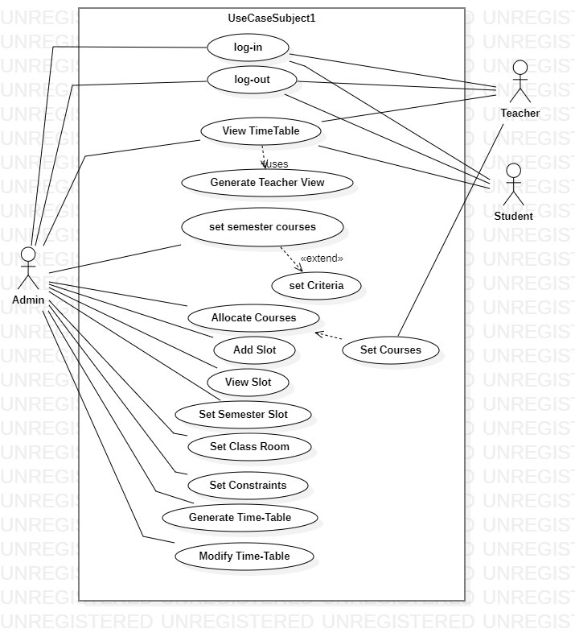

## 

## 2.2 Use Cases Distribution

|  |  |  |
| --- | --- | --- |
| S#. | Group Member | Assigned Use Cases |
| 1 | <BASIT IQBAL>  <FA21-BSE-050> | UC 1 : Login  UC 2: Logout |
| 2 | <Fatima Aftab>  <FA21-BSE-088> | UC 3: Generate timetable  UC 4: Modify Timetable |
| 3 | <Waleed Rashid>  <FA21-BSE-162> | UC 5 : Set slots.  UC 6 : Add slots.  UC 7 : View slots |
| 4 | <Ahmed Tariq>  <FA21-BSE-048> | UC 8 : Set semester’s courses.  UC 9: :Set Constrains.  UC 10 : Set criteria |
| 5 | <Eissa Masood>  <FA21-BSE-086> | UC 11 : Allocate courses.  UC 12: select rooms.  UC 13: select courses. |
| 6 | <Ebadat Nissa Khan>  <FA21-BSE-085> | UC 14 : View Timetable  UC 15: View Teachers Timetable  UC 16: View Timetable by Student |

## 2.3 Brief Level Use Cases

### Eissa Masood (FA21-BSE-086)

#### Use Case: Allocate Courses

The Timetable Management System for a university is a crucial tool for allocating courses to the timetable for each academic term. The primary actor in this use case is the System Admin, who logs into the system and selects the academic term for which courses need to be allocated. The system displays the available courses, and the admin selects the courses to be allocated. The system checks for scheduling conflicts and suggests alternative options if necessary. The admin reviews and approves the suggested options, and the system assigns the courses to the timetable. If modifications are needed, the admin can modify the allocated courses by selecting the desired scheduling options. The updated timetable is generated and displayed in the system, and the courses are now allocated for the selected academic term.

### Eissa Masood (FA21-BSE-086)

#### Use Case: Select Teacher

The "Select Teacher" use case in a Timetable Management System allows admin to select teachers to teach the allocated courses. Once the courses have been allocated to the timetable, the admin can assign the courses to a teacher based on their availability and expertise in the subject area. The system displays a list of available teachers, along with their qualifications and availability for the selected time slots. The admin selects the desired teacher and assigns them to the course. The system updates the timetable accordingly, and the assigned teacher is notified of their teaching assignment. This use case ensures that each course is assigned to a qualified and available teacher, and it allows for efficient and effective management of the university's teaching resources.

### Ebadat Nissa Khan (FA21-BSE-085)

#### Use Case: View time table

The "View Timetable" use case is a fundamental feature of the Timetable Management System for University. This use case enables students and teachers to view their class schedules for the current week or multiple weeks in advance. The system displays the timetable information accurately and in a user-friendly format, including the course code, course name, class start and end time, and class location. The success of this use case guarantees that students and teachers can plan their schedules, accordingly, attend their classes on time, and avoid any scheduling conflicts. The View Timetable use case occurs multiple times per week for each student and teacher, and it is essential to the success of the Timetable Management System.

### Ebadat Nissa Khan (FA21-BSE-085)

#### Use Case: View time student table

The "View Timetable by Student" is a use case within the Timetable Management System for University, which allows students to access their class schedules. This use case is of high importance, as it ensures that students have a clear understanding of their class schedules and can attend their classes on time. The use case occurs at the user goal level, meaning it is a significant task that students need to accomplish to achieve their academic goals. The primary actor for this use case is the student, and the stakeholders are the faculty and university administration. The student must have an active account in the system and have already enrolled in the classes they wish to view on the timetable. The success of this use case guarantees that students can view their timetable with accurate information and plan their schedules accordingly. It occurs multiple times per week for each student and is critical to the success of the Time Table Management System.

### Ebadat Nissa Khan (FA21-BSE-085)

#### Use Case: View teacher time table

The "View Timetable by Teacher" is a use case within the Time Table Management System for University, which allows teachers to access their class schedules. This use case is of high importance, as it ensures that teachers have a clear understanding of their class schedules and can attend their classes on time. The use case occurs at the user goal level, meaning it is a significant task that teachers need to accomplish to achieve their academic goals. The primary actor for this use case is the teacher, and the stakeholders are the faculty and university administration. The teacher must have an active account in the system and have already been assigned to the classes they wish to view on the timetable. The success of this use case guarantees that teachers can view their timetable with accurate information and plan their schedules accordingly.

### Ahmed Tariq (FA21-BSE-048)

#### Use Case: Set semester courses

### In a time table management system, set semester courses are the courses that are offered during a specific semester or academic term. These courses can be categorized based on various factors.

### Set semester courses are important for a time table management system as they form the basis for creating the class schedule for that semester. The system needs to ensure that all courses offered in a particular semester are scheduled in such a way that there are no conflicts in the course schedules.

### To manage semester courses effectively, a time table management system may use different techniques such as clustering courses based on similarity, grouping courses based on the availability of the required resources such as classrooms and lab equipment, and scheduling courses based on student demand and faculty availability.

### Ahmed Tariq (FA21-BSE-048)

#### Use Case: Set Criteria

In a time table management system, set criteria are used to determine how the schedule is generated. These criteria can be defined based on various factors, such as student preferences, teacher workload, room availability, and overall program requirements.

Some common set criteria that might be used in a time table management system include:

1. Student preferences: This criterion considers the preferences of individual students when scheduling their classes. For example, some students may prefer to have their classes scheduled in the morning, while others may prefer afternoon or evening classes.
2. Teacher workload: This criterion ensures that each teacher is assigned a workload that is appropriate for their level of experience and expertise. For example, new teachers may be assigned fewer classes than experienced teachers.
3. Room availability: This criterion ensures that each class is scheduled in an available classroom that is appropriate for the class size and equipment needs. For example, a class that requires a computer lab may be scheduled in a room with the necessary equipment.
4. Program requirements: This criterion ensures that the schedule meets the overall requirements of the academic program. For example, a program may require that certain classes be taken in a specific order, or that certain classes be completed before graduation.

By defining and applying set criteria in a time table management system, administrators can generate schedules that are efficient, effective, and meet the needs of all stakeholders involved. Set criteria help to ensure that resources are utilized effectively, scheduling conflicts are minimized, and optimal learning outcomes are achieved for all students

### Ahmed Tariq (FA21-BSE-048)

#### Use Case: Set Constrains

#### In a time table management system, set constraints are used to ensure that the schedule meets certain conditions or requirements. These constraints can take various forms, including course availability, classroom availability, teacher availability, student availability, and room capacity.

#### Course availability constraints ensure that each course is scheduled during specific days and times. Classroom availability constraints ensure that each class is assigned to an available classroom. Teacher availability constraints ensure that each teacher is available to teach during the scheduled time slot. Student availability constraints ensure that each student is able to attend all their registered classes without conflicts. Room capacity constraints ensure that each class is assigned to a classroom with sufficient capacity.

#### By incorporating these and other set constraints, a time table management system can generate a schedule that is efficient, effective, and meets the needs of all stakeholders involved, including students, teachers, and administrators. Set constraints help to prevent scheduling conflicts, ensure that resources are utilized effectively, and promote optimal learning outcomes for all students.

### Waleed Rashid (FA21-BSE-162)

#### Use Case: Manage slots.

|  |
| --- |

The academic administrator can add a new slot to the timetable by selecting a course or exam, assigning it to an available room, and choosing a suitable time slot. The academic administrator can modify an existing slot by changing the room or time slot, or by reassigning the course or exam to another faculty member. The academic administrator can cancel a slot if the course or exam is no longer required or needs to be rescheduled. The system should automatically update the timetable and notify all stakeholders of the change. The academic administrator can view all available slots, including those already assigned and those that are still open. The system should provide filters and search options to help the administrator locate specific slots.

### Fatima Aftab (FA21-BSE-088)

#### Use Case: Generate Timetable

The "generate timetable" use case involves the generation of a schedule for a specific time based on predefined criteria such as course offerings, class size, available classrooms, slots, and teacher availability. The Admin selects the criteria and inputs the necessary data, such as course names, class sizes, slots, and teacher schedules, into the system. The system then uses an algorithm to generate a timetable that meets all the specified criteria, while also considering any constraints, such as avoiding scheduling conflicts or ensuring that certain courses are offered at specific times. Once the timetable has been generated, the Admin can review and modify it as necessary before finalizing it. The generated timetable can then be printed or exported for distribution to students, and teachers.

### Fatima Aftab (FA21-BSE-088)

#### Use Case: Modify Timetable

"Modify timetable" is a critical use case for a university timetable generation system. It involves making changes to the schedule to adapt to various circumstances, such as course offerings, student preferences, and resource utilization. This use case is important to avoid scheduling conflicts and ensure that students have access to the courses they need. By modifying the system, universities can create a schedule that meets the needs of students and faculty, maximizes the use of resources, and provides the best possible learning experience. Ultimately, a flexible and adaptable timetable generation system is crucial to the success of any academic institution.

## 2.4 Fully Dressed Use Cases

### BASIT IQBAL (FA21-BSE-050)

| Use Case UC1: Login |
| --- |

|  |  |
| --- | --- |
| Use Case Section | Comments |
| Use Case Name | Login |
| Scope | University Timetable Generation System |
| Level | User Goal |
| Primary Actor. | Admin, student, teacher |
| Stakeholders and interest | * System Admin: Wants to efficiently login to the system to use the services being offered by the system. * Teachers: Wants to efficiently login to the system to use the services being offered by the system. * Students: Wants to efficiently login to the system to use the services being offered by the system. |
| Preconditions | The User must have a valid username and password (i.e Registration must have been completed). |
| Success Guarantee | The user is logged in to the system and can perform actions within it |
| Main Success Scenario | 1. The user navigates to the login page 2. The user enters their username and password 3. The system verifies the user's credentials. 4. If the credentials are correct, the system grants access to the system and the user can perform actions within it. |
| Exceptions | 1. If the user enters an incorrect username or password, the system displays an error message and prompts the user to try again. 2. If the user forgets their password, they can click on the "Forgot Password" link and follow the password recovery process. |
| Special Requirements | * The Timetable Management System should be user-friendly and easy to navigate. * The system should provide a clear overview of the available courses and their scheduling options. * The system should allow for easy modifications to the allocated courses. |
| Technology and data  variation list. | * The Timetable Management System can be accessed from a web browser or a dedicated application. * The system should be compatible with various operating systems and devices. * The list of available courses may vary depending on the academic term and the university's course offerings. |
| Frequency of occurrences | This use case occurs at the beginning when the user navigates to the website of the university timetable generation system or open the desktop application |
| Miscellaneous | * The Timetable Management System should be regularly updated and maintained to ensure optimal performance and usability. * The system should have appropriate security measures in place to protect user data and prevent unauthorized access. |

### BASIT IQBAL (FA21-BSE-050)

| Use Case UC2: Log out |
| --- |

|  |  |
| --- | --- |
| Use Case Section | Comments |
| Use Case Name | Log Out |
| Scope | University Time Table Generation System |
| Level | User Goal |
| Primary Actor. | Admin, student, teacher |
| Stakeholders and interest | * System Admin: Wants to logout off the system after using the services and wants privacy and security of the account. * Faculty Members: Wants to logout off the system after using the services and wants privacy and security of the account. * Students: Wants to logout off the system after using the services and wants privacy and security of the account. |
| Preconditions | * The user is currently logged in to the system. * The user has access to the internet. |
| Success Guarantee | * The user is logged out of the system. * The user is redirected to the login screen. |
| Main Success Scenario | * The user clicks on the "Log out" button or link in the user interface. * The system logs the user out by invalidating their session token or cookie. * The system redirects the user to the login screen. |
| Exceptions | 1. Automatic log out due to session timeout:   If the user's session has been inactive for a certain period of time, the system automatically logs the user out and invalidates their session token or cookie.  The system displays a message to the user indicating that they have been logged out due to inactivity and redirects them to the login screen.   1. Error during log out process:   If an error occurs during the log out process, such as the system being unable to invalidate the session token or cookie, the system displays an error message to the user and asks them to try again or contact support.   1. User is already logged out:   If the user has already been logged out, either by clicking the "Log out" button or automatically due to a session timeout, the system displays a message to the user indicating that they are already logged out and redirects them to the login screen. |
| Special Requirements | * The Timetable Management System should be user-friendly and easy to navigate. * The system should provide a clear overview of the available courses and their scheduling options. * The system should allow for easy modifications to the allocated courses. |
| Technology and data  variation list. | * The Timetable Management System can be accessed from a web browser or a dedicated application. * The system should be compatible with various operating systems and devices. * The list of available courses may vary depending on the academic term and the university's course offerings. |
| Frequency of occurrences | This use case occurs at the last when the user navigates to the website of the university timetable generation system or open the desktop application and has performed all the actions of his choice and wants to leave the system by clicking on logout. |
| Miscellaneous | * The Timetable Management System should be regularly updated and maintained to ensure optimal performance and usability. * The system should have appropriate security measures in place to protect user data and prevent unauthorized access. |

### Waleed Rashid(FA21-BSE-162)

| Use Case UC1: Manage slots |
| --- |

|  |  |
| --- | --- |
| Use Case Name | Manage Slot in Timetable Management System for University |
| Scope | Timetable Management System for the university |
| Level | User Goal Level |
| Primary Actor | Academic Administrator |
| Stakeholders and Interests | **Faculty**: Interested in having their classes scheduled at appropriate times and rooms  **Students**: Interested in having their classes scheduled without any conflicts and preferences considered  **Room** Administrators: Interested in ensuring that rooms are utilized efficiently and not overbooked.  **University** Administration: Interested in efficient scheduling to maximize resource utilization and minimize conflicts |
| Precondition | The administrator is authenticated and authorized to access the Timetable Management System, and the timetable is set up with the available courses, faculty, rooms, and other resources |
| Success Guarantee | Successful scheduling of classes, labs, and exams without any conflicts or overbooking of resources |
| Main Success Scenarios | The administrator selects the course or exam for which the slot needs to be scheduled.  The system presents the available time slots for the selected course/exam and checks for any conflicts.  The administrator selects the appropriate time slot and assigns it to the course/exam.  The system updates the timetable and notifies the faculty and students of the new schedule. |
| Exceptions | If there are no available time slots, the system alerts the administrator and suggests alternative solutions.  If there is a conflict with a previously scheduled course or exam, the system alerts the administrator and suggests alternative time slots or adjustments to the existing schedule.  if there are not enough resources (such as rooms or faculty) to schedule a course or exam, the system alerts the administrator and suggests alternative solutions. |
| Special Requirements | The system should be able to handle multiple constraints such as avoiding time conflicts, ensuring the availability of required equipment, and accommodating student preferences as much as possible. |
| Technology and Data Variation List | The system should be able to integrate with the university's existing information systems and databases, including course catalogs, faculty information, and room availability data. |
| Frequency of Occurrences | Multiple times per academic term, typically during the course scheduling and exam scheduling periods. |
| Prototype | A prototype of the system should be developed and tested with input from faculty, students, and administrators to ensure it meets their needs and expectations. |
| Miscellaneous | This use case is critical for the efficient operation of the university and can have a significant impact on the academic success of faculty and students. Therefore, it should be designed and implemented with care and attention to detail. |
| Use Case Section | Time Table Management |
| Primary Actors | Academic Administrator |
| Secondary Actors | Faculty, Students, Room Administrators, University Administration |
| Preconditions | The administrator is authenticated and authorized to access the Time Table Management System, and the timetable is set up with the available courses, faculty, rooms, and other resources |
| Post conditions | The system updates the timetable and notifies the faculty and students of the new schedule. |
| Related Use Cases | Manage Course, Manage Exam, Manage Room, Manage Faculty |
| Special Requirements | The system should be able to handle multiple constraints such as avoiding time conflicts, ensuring the availability of required equipment, and accommodating student preferences as much as possible. |

### Eissa Masood (FA21-BSE-086)

| Use Case UC1: Allocate Course |
| --- |

|  |  |
| --- | --- |
| Use Case Section | Comments |
| Use Case Name | Allocate Courses. |
| Scope | This use case describes the process of allocating courses to the timetable for a new academic term in the Timetable Management System. |
| level | User Goal |
| Primary Actor. | Admin |
| Stakeholders and interest | * System Admin: Wants to efficiently allocate courses to the timetable for each academic term. * Faculty Members: Want to ensure that their courses are allocated to the timetable at a convenient time and day. * Students: Want a well-structured and organized timetable that minimizes scheduling conflicts and allows for an optimal learning experience. |
| Preconditions | The Timetable Management System is operational.  The Admin has the necessary login credentials to access the system.  The list of available courses for the academic term is available in the system. |
| Success Guarantee | The courses are allocated to the timetable , and the updated timetable is generated and displayed in the system |
| Main Success Scenario | 1. The admin logs into the Timetable Management System. 2. The admin selects the academic term for which courses need to be allocated. 3. The system displays the list of available courses for the selected term. 4. The admin selects the courses that need to be allocated to the timetable. 5. The system checks for any scheduling conflicts with previously allocated courses. 6. If there are no conflicts, the system assigns the selected courses to the timetable. 7. If there are conflicts, the system suggests alternative scheduling options. 8. The admin approves the suggested scheduling options. 9. The system assigns the courses to the timetable according to the approved scheduling options. 10. The system generates and displays the updated timetable. |
| Exceptions | 1. If the Timetable Management System is not operational, the use case cannot proceed. 2. If the admin does not have the necessary login credentials, they cannot access the system. 3. If the list of available courses for the academic term is not available in the system, the admin cannot allocate courses to the timetable. |
| Special Requirements | * The Timetable Management System should be user-friendly and easy to navigate. * The system should provide a clear overview of the available courses and their scheduling options. * The system should allow for easy modifications to the allocated courses. |
| Technology and data  variation list. | * The Timetable Management System can be accessed from a web browser or a dedicated application. * The system should be compatible with various operating systems and devices. * The list of available courses may vary depending on the academic term and the university's course offerings. |
| Frequency of occurrences | This use case occurs at the beginning of each academic term, typically once a year. |
| Miscellaneous | * The Timetable Management System should be regularly updated and maintained to ensure optimal performance and usability. * The system should have appropriate security measures in place to protect user data and prevent unauthorized access. |

### Eissa Masood (FA21-BSE-086)

| Use Case UC1: Select Teacher |
| --- |

|  |  |
| --- | --- |
| Use Case Section | Comments |
| Use Case Name | Select Teacher. |
| Scope | This use case describes the process of selecting and assigning a teacher to an allocated course in the Timetable Management System. |
| level | User Goal |
| Primary Actor. | Admin |
| Stakeholders and interest | * Admin: Wants to efficiently assign qualified and available teachers to the allocated courses. * Faculty Members: Want to ensure that the courses they are teaching are properly assigned to them in the timetable. * Students: Want to have a well-structured and organized timetable with qualified teachers teaching their courses. |
| Preconditions | * The Timetable Management System is operational. * The admin has the necessary login credentials to access the system. * The courses have been allocated to the timetable. |
| Success Guarantee | The selected teacher is assigned to the allocated course, and the updated timetable is generated and displayed in the system. |
| Main Success Scenario | 1. The admin logs into the Timetable Management System. 2. The admin selects the academic term and the allocated course for which a teacher needs to be selected. 3. The system displays a list of available teachers for the selected time slot and subject area. 4. The admin selects the desired teacher from the list. 5. The system checks for any scheduling conflicts with the teacher's existing assignments. 6. If there are no conflicts, the system assigns the teacher to the course. 7. If there are conflicts, the system suggests alternative scheduling options. 8. The admin approves the suggested scheduling options. 9. The system assigns the teacher to the course according to the approved scheduling options. 10. The system generates and displays the updated timetable. |
| Exceptions | 1. if the Timetable Management System is not operational, the use case cannot proceed. 2. If the admin does not have the necessary login credentials, they cannot access the system. 3. If the courses have not been allocated to the timetable, a teacher cannot be selected for the course. 4. If there are no available teachers for the selected time slot and subject area, the use case cannot proceed. |
| Special Requirements | * The Timetable Management System should provide a clear overview of the available teachers and their qualifications and availability. * The system should allow for easy modifications to the assigned teachers. * The system should have appropriate security measures in place to protect user data and prevent unauthorized access. |
| Technology and data  variation list. | * The Timetable Management System can be accessed from a web browser or a dedicated application. * The system should be compatible with various operating systems and devices. * The list of available teachers may vary depending on their availability and expertise in the subject area. |
| Frequency of occurrences | This use case occurs whenever a new academic term starts or when there is a change in the teaching assignments. |
| Miscellaneous | * The Timetable Management System should be regularly updated and maintained to ensure optimal performance and usability. * The system should be able to handle multiple teacher assignments for different courses and time slots. * The system should be able to send notifications to the assigned teacher regarding their teaching assignment. |

### Ahmed Tariq (FA21-BSE-048)

| Use Case UC1: Set Semester courses |
| --- |

|  |  |
| --- | --- |
| Use Case Section | Comments |
| Use Case Name | Set Semester Courses |
| Scope | This use case involves set semester courses offered by the University within the Timetable Management System. |
| Main Success Scenarios | 1. Academic Staff selects the "Set Semester Courses" option from the system menu. 2. System displays the list of available courses for the semester. 3. Academic Staff selects the courses they want to set for the semester and submits their choices to the system. 4. System checks for any conflicts in the selected courses and notifies the Academic Staff if there are any conflicts. 5. Academic Staff resolves any conflicts by either selecting alternate course timings or removing conflicting courses. 6. System generates a conflict-free timetable for the semester and displays it to the Academic Staff. 7. Academic Staff reviews and confirms the timetable. 8. System saves the selected courses and timetable data |
| Level | User goal |
| Primary Actor | University Administrator |
| Stakeholders | Professors, Students, University Administration, |
| Preconditions | * The University Administrator is logged in to the Timetable Management System. * Academic Staff must be authenticated and have the necessary permissions to set semester courses. * Course data for the semester must be available in the system. |
| Success Guarantee | Semester courses are successfully set and the timetable is conflict-free. |
| Exceptions | 1. Academic Staff selects an invalid course or course time. 2. System encounters an error while generating the timetable. 3. System detects a conflict but fails to notify the Academic Staff. 4. Academic Staff is unable to resolve conflicts and create a conflict-free timetable. |
| Special Requirements | None |
|  |  |
| Technology and Data Variations List | * System must have access to the list of available courses for the semester. * System must be able to generate a conflict-free timetable. * System must be able to save the selected courses and timetable data. |
| Frequency of Occurrences | Once per semester. |
|  |  |
| Miscellaneous | None |
|  |  |
|  |  |
|  |  |
|  |  |
|  |  |

### Ahmed Tariq (FA21-BSE-048)

| Use Case UC1: Set Criteria |
| --- |

|  |  |
| --- | --- |
| Use Case Section | Comments |
| Use Case Name | Set Criteria |
| Scope | This use case involves setting criteria in the TimeTable Management System for the University. |
| Main Success Scenarios | 1. Academic Staff selects the "Set Criteria" option from the system menu. 2. System displays the current criteria for generating conflict-free timetables. 3. Academic Staff modifies the criteria according to their preferences. 4. System saves the new criteria and updates the system's conflict-free timetable generation algorithm. 5. System notifies the Academic Staff that the criteria have been successfully set. |
| Level | User goal |
| Primary Actor | University Administrator |
| Stakeholders | Professors, Students, University Administration, |
| Preconditions | * Academic Staff must be authenticated and have the necessary permissions to set criteria. * Course data for the semester must be available in the system. |
| Success Guarantee | Criteria for generating conflict-free timetables is successfully set. |
| Exceptions | 1. Academic Staff selects an invalid criteria value. 2. System encounters an error while updating the conflict-free timetable generation algorithm. |
| Special Requirements | None |
|  |  |
| Technology and Data Variations List | * System must have access to the current conflict-free timetable generation algorithm and criteria. * System must be able to update the conflict-free timetable generation algorithm with the new criteria. |
| Frequency of Occurrences | As needed. |
|  |  |
| Miscellaneous | None. |
|  |  |
|  |  |
|  |  |
|  |  |
|  |  |

### Ahmed Tariq (FA21-BSE-048)

| Use Case UC1: Set Constrains |
| --- |

|  |  |
| --- | --- |
| Use Case Section | Comments |
| Use Case Name | Set Constrains |
| Scope | This use case involves setting constrains in the TimeTable Management System for the University. |
| Main Success Scenarios | 1. Academic Staff selects the "Set Constraints" option from the system menu. 2. System displays the current constraints for generating conflict-free timetables. 3. Academic Staff modifies the constraints according to their preferences. 4. System saves the new constraints and updates the system's conflict-free timetable generation algorithm. 5. System notifies the Academic Staff that the constraints have been successfully set. |
| Level | User goal |
| Primary Actor | University Administrator |
| Stakeholders | Professors, Students, University Administration, |
| Preconditions | * Academic Staff must be authenticated and have the necessary permissions to set constraints. * Course data for the semester must be available in the system. |
| Success Guarantee | Constraints for generating conflict-free timetables is successfully set. |
| Exceptions | 1. Academic Staff selects an invalid constraint value. 2. System encounters an error while updating the conflict-free timetable generation algorithm. |
| Special Requirements | None. |
|  |  |
| Technology and Data Variations List | * System must have access to the current conflict-free timetable generation algorithm and constraints. * System must be able to update the conflict-free timetable generation algorithm with the new constraints. |
| Frequency of Occurrences | As needed. |
|  |  |
| Miscellaneous | None. |
|  |  |
|  |  |
|  |  |
|  |  |
|  |  |

### FATIMA AFTAB (FA21-BSE-088)

| Use Case UC4: Generate Timetable |
| --- |

|  |  |
| --- | --- |
| Use Case Section | Comments |
| Use Case Name | Generate Timetable |
| Scope | University timetable |
| Main Success Scenarios | 1. The administrator selects the "Generate Timetable" option from the main menu. 2. The system displays a form where the administrator can enter the details of the timetable, such as the start and end date, the number of courses, the number of classrooms, and the number of students. 3. The administrator fills out the form and submits it to the system. 4. The system checks the validity of the input and generates a list of available time slots based on the input parameters. 5. The system uses an algorithm to generate a conflict-free timetable that allocates the available time slots to the courses and classrooms. 6. The system displays the generated timetable to the administrator. 7. The administrator reviews the timetable and verifies that it meets the requirements of the faculty and students. 8. If the timetable is satisfactory, the administrator approves it and saves it in the system. 9. If the timetable is not satisfactory, the administrator can modify and re-generate the timetable. |
| Level | User goal |
| Primary Actor | University Administrator |
| Stakeholders | * University administrator: Wants to generate an accurate and efficient timetable for the university to ensure that students and faculty can attend classes without conflicts. * Faculty: Need to know when and where their classes are scheduled. * Students: Need to know when and where their classes are scheduled. |
| Preconditions | * University administrator should login to the system. * The system has been set up with the necessary data, including course schedules, faculty availability, room availability, and other constraints. * The system has assigned courses to faculty members and recorded their preferences. |
| Success Guarantee | The system generates a timetable that meets the expectations and requirements of all stakeholders. |
| Exceptions | * If the system is unable to generate a conflict-free timetable, it should display an error message and prompt the Admin to modify the scheduling algorithm or parameters. * If there is a system error while generating the timetable, the system should display an error message and prompt the admin to try again later. * If there is a major change in faculty availability or course enrollment after the timetable has been generated, the admin may need to modify the schedule manually. |
| Special Requirements | The Timetable System must be able to generate accurate course schedules based on the classrooms available. |
|  |  |
| Technology and Data Variations List | * Object-Oriented Programming * Database Management Systems * Object Oriented Software Engineering * Web languages (html, CSS, react) * Course information may be updated between the time the timetable is generated and the start of the semester. * Faculty availability may change due to illness, scheduling conflicts, or other unforeseen circumstances. * Classroom availability may change due to maintenance or other scheduling conflicts |
| Frequency of Occurrences | * Once per semester for each university department. * If timetable is not accurate university administrator can also modify it. |
|  |  |
| Miscellaneous | * The system should be able to handle large amounts of data efficiently. * The system should be user-friendly and easy to navigate. * The system should be able to generate a timetable within a reasonable amount of time. |
|  |  |
|  |  |
|  |  |
|  |  |
|  |  |

### FATIMA AFTAB (FA21-BSE-088)

| Use Case UC5: Modify timetable |
| --- |

|  |  |
| --- | --- |
| Use Case Section | Comments |
| Use Case Name | Modify timetable |
| Scope | University Timetable |
| Level | User Goal |
| Primary Actor. | University Administrator |
| Stakeholders and interest | * University Administrator : A person who is responsible for managing and wants to make changes to the timetable in a quick and efficient manner. |
| Preconditions | * User authentication : The user must be authenticated and authorized as an administrator with the necessary permissions to make changes to the timetable. * Timetable existence : The timetable must already exist in the system for the administrator to modify it. |
| Success Guarantee | * The changes made by the administrator are accurately reflected in the timetable. * The timetable for teachers, and students are updated to reflect the changes made in it. |
| Main Success Scenario | * The administrator selects the "Modify Timetable" option from the system menu. * The administrator selects the course, teacher, or classroom they wish to modify from the available options. * The administrator modifies the schedule information for the selected course, teacher, or classroom as necessary. * The system updates the timetable to reflect the changes made by the administrator. * Faculty and students can access the updated schedules and any changes made to the timetable. |
| Exceptions | * The timetable the administrator is attempting to modify does not exist in the system. * The course, faculty, or classroom the administrator is attempting to modify does not exist in the system. * The changes made by the administrator result in a conflict with an existing schedule for a course, instructor, or classroom. * The administrator inputs invalid or incomplete schedule information, such as an incorrect time or room number. * A system error occurs during the modification process and prevents the changes from being correctly updated in the system. |
| Special Requirements | * Usability: The system should have a user-friendly interface that is easy for administrators to navigate and use to modify the timetable. * Security: The system should ensure that only authorized administrators with the appropriate permissions can modify the timetable, and that user data is securely stored and protected from unauthorized access or tampering. * Reliability: The system should be reliable and available for administrators to always use, with minimal downtime for maintenance or updates. |
| Technology and data  variation list. | * Object-Oriented Programming * Database Management Systems * Object Oriented Software Engineering * Web technologies (html,css,react) * Java for GUI |
| Frequency of occurrences | It depends upon the administrator that how many times he/she wants to modify timetable after the timetable has been generated. |
| Miscellaneous | * The system should be able to handle large amounts of data efficiently. * The system should be user-friendly and easy to navigate. * The system should be able to modify timetable correctly and update timetable for teachers, and students. |

# CHAPTER 3 DOMAIN MODEL

## 3.1 Individual Partial Domain Model

### UC 1,2 : Login & Logout (BASIT IQBAL ,FA21-BSE-050)

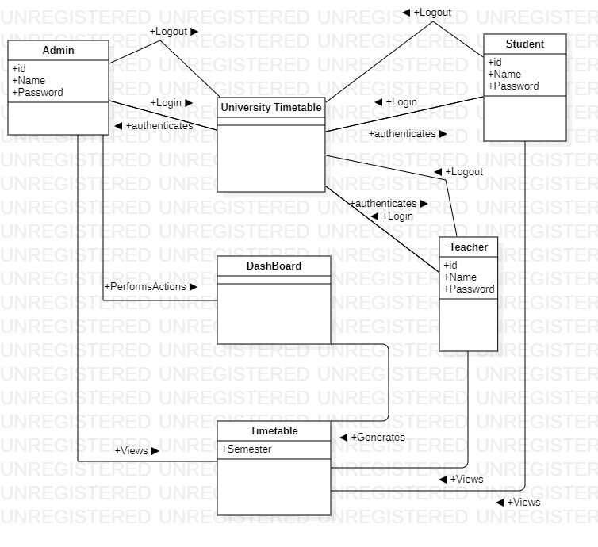

### UC 3,4 : Generate Timetable and Modify timetable (Fatima Aftab,Fa21-bse-088)

### Manage slots(Waleed Rashid, FA21-BSE-162)

# CHAPTER 4 SYSTEM SEQUENCE DIAGRAM

## System Sequence Diagram of each Scenario

### LOGIN (BASIT IQBAL : FA21-BSE-050)

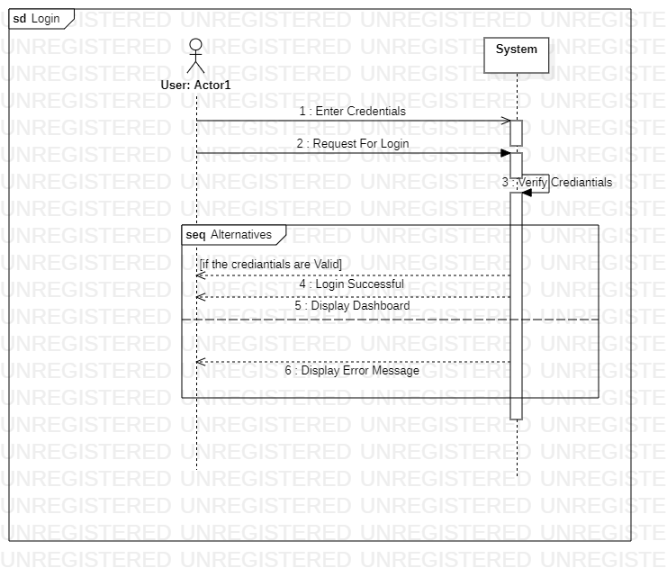

### Logout (BASIT IQBAL : FA21-BSE-050)

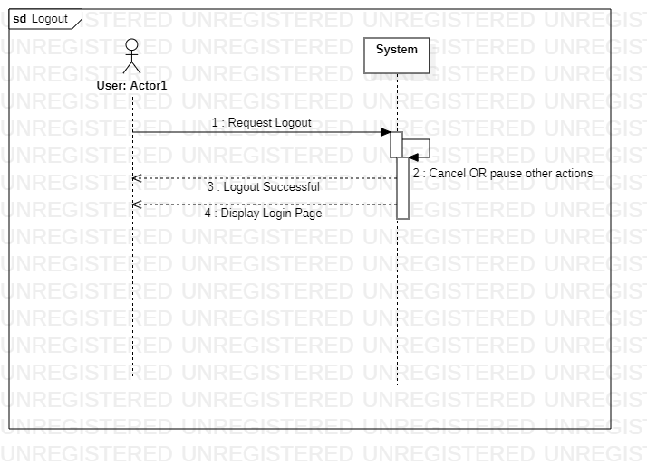

### Generate Timetable Scenario (Fatima Aftab)

### Modify Timetable Scenario (Fatima Aftab)

### Manage Slots (Waleed Rashid)

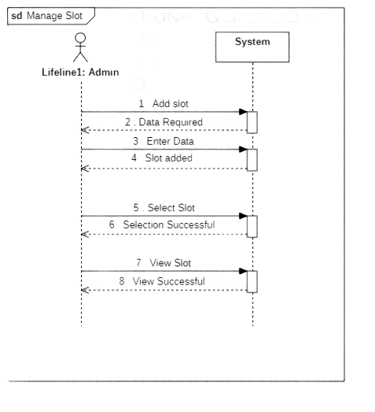

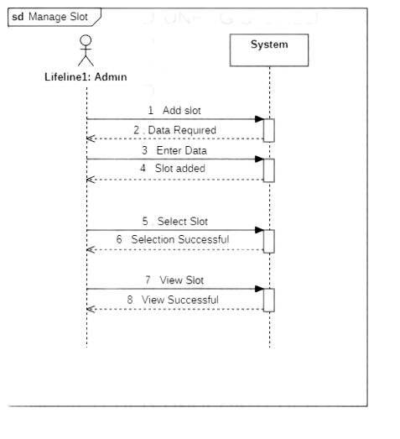

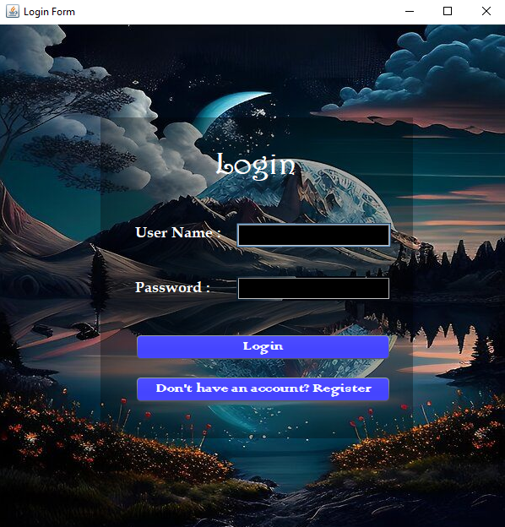LOGIN FORM:

REGISTRATION FORM:

